Getting legumes into pastures

Pasture legumes can improve the productivity of grass–pastures, but they can be difficult to establish and maintain in a pasture.

Why should legumes be introduced?
- Increase weight gain (kg/beast / kg/ha): can add an extra 30–60 kg/beast/yr.
- Contribute nitrogen to the soil: grass quality is increased.
- Produce higher quality feed when grasses are mature, particularly in autumn/winter.

Pasture rundown
- Nitrogen is ‘tied–up’ in forms unavailable to plants – reduces grass growth and animal growth rates performance.
- Different to rundown of cropping soils, where nutrients are removed.
- To overcome, grass material (litter, root mass) needs to be decomposed, or plant legumes to increase nitrogen supply.

How to establish legumes?
A number of options are available, but the best results are obtained from direct seed–soil contact and reducing/eliminating grass competition.

1. Broadcast onto surface:
- Primarily successful for Stylos, but might be possible for other legumes (e.g. burgundy bean).
- Easy but risky option as relies heavily on follow–up rainfall for success.

2. Bandseeding:
- Plant seeds with zero till type tynes followed by presswheels. Follow–up with a band of herbicide such as glyphosate to minimise grass competition.
- Higher establishment potential as seed is in direct contact with soil, and competition (grass) has been suppressed.

3. Zero till:
- Spray out all grass after first or second rainfall event in spring
- Once 30–45 cm of moisture stored, plant seed into moisture followed by presswheels with a zero till planter
- Higher cost but significantly higher success rate. Grasses will self–regenerate.

4. Minimum disturbance tillage:
- Single pass with offset discs, chisel plough or crocodile planter to create soil roughness and let moisture in.
- Success will depend on the amount of grass removed and follow–up rainfall.

5. Full disturbance tillage:
- Fully cultivate with discs or chisel plough to provide seedbed.
- Store moisture and plant seed in ground with combine/airseeder, or surface application with drumseeder and tyre roller.
- Good option if a zero till planter is not available.

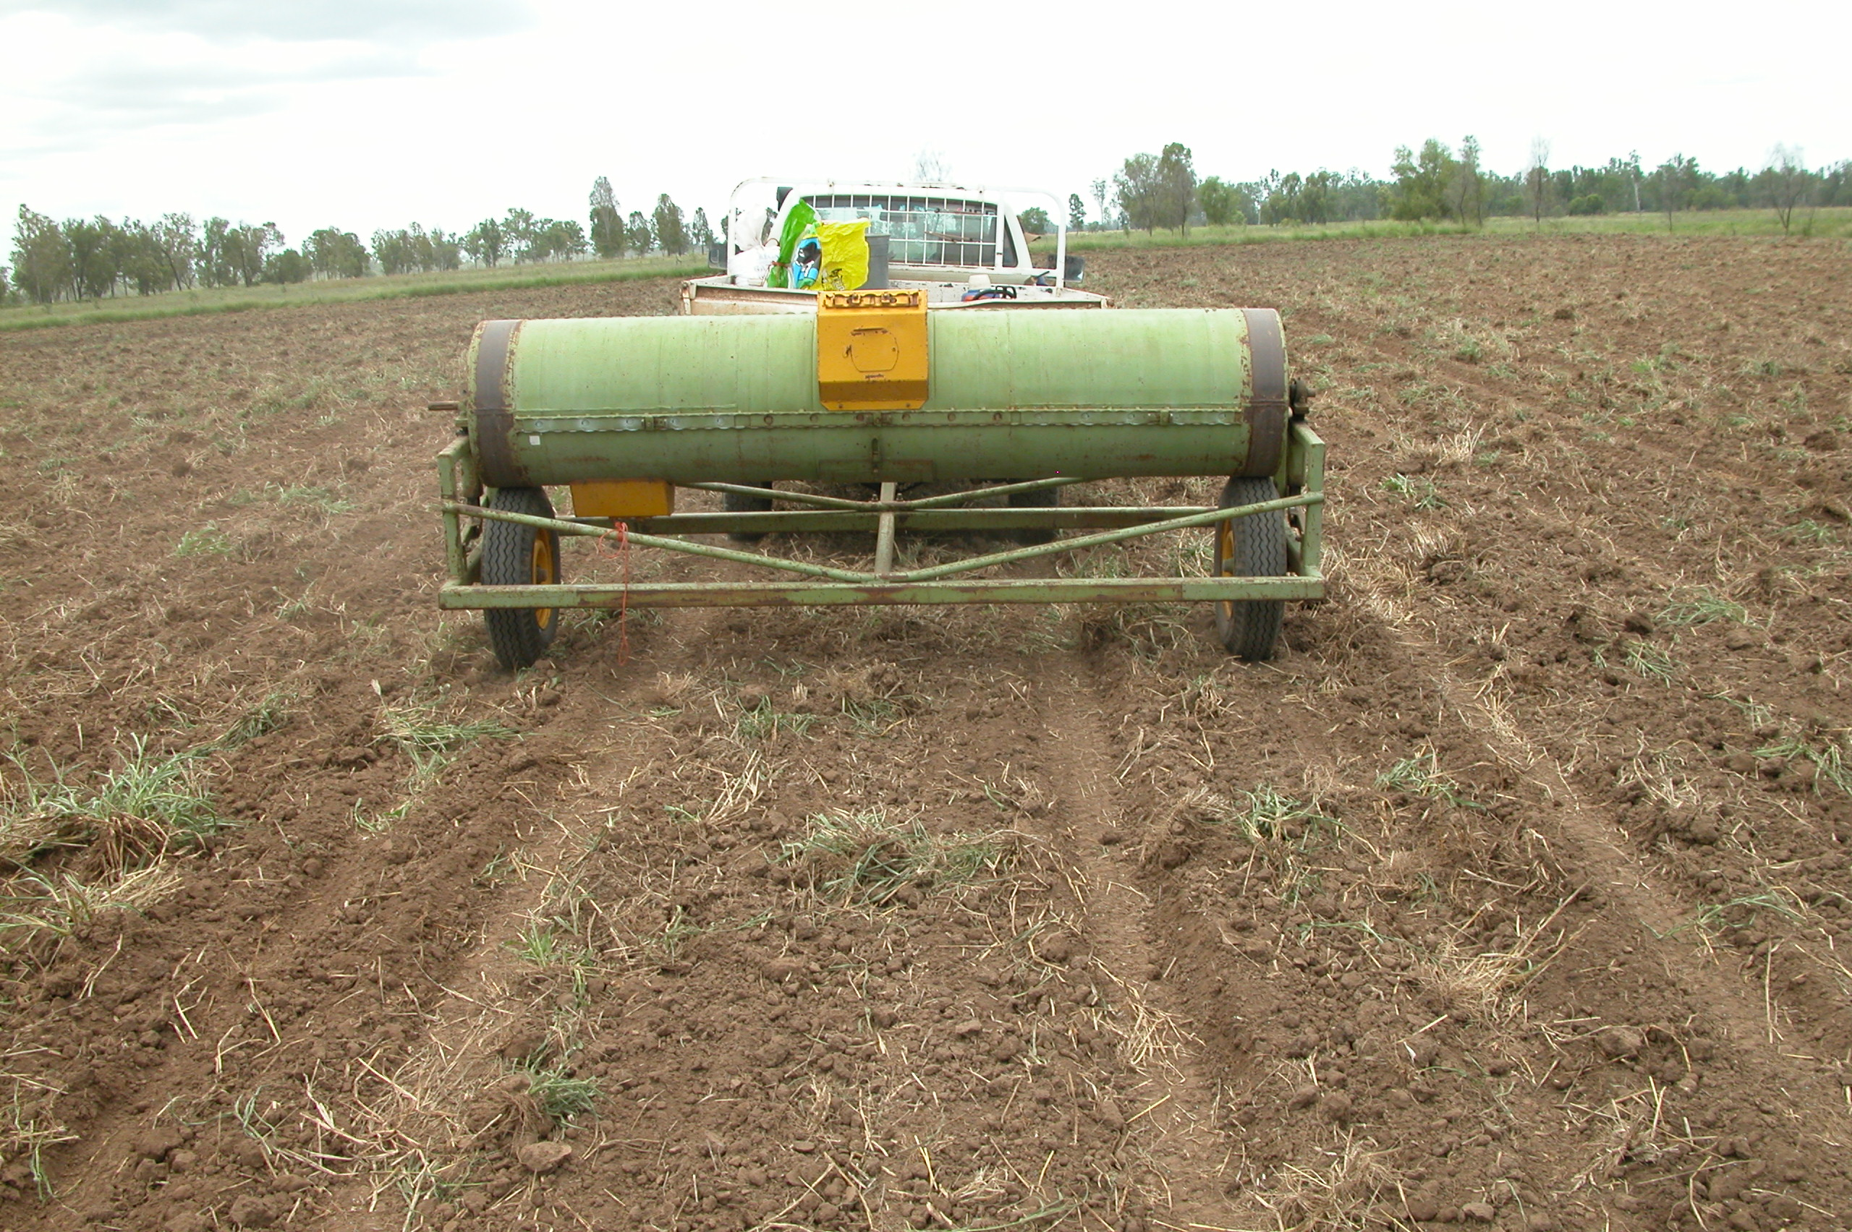

Pasture legumes suitable for Central Queensland conditions:
Land type | Seca Stylo | Caatinga stylo | Leucaena | Butterfly pea | Burgundy bean | Siratro | Desmanthus | Lucerne
Brigalow
- softwood scrub
- grey/yellow clays
- melonhole clay
- Blackbutt duplex
Open downs
- grassland black clay
- woodland shallow clay
Alluvial flats
- heavy clay (e.g. Coolibah)
- Loam (e.g. Bluegum)
Forest
- Eucalypt woodlands
Suited
Will grow, but difficult to establish or persistence poor.
Unsuited

Further information
Stuart Buck (Central Queensland): Brian Johnson (Southern Queensland):
DAFF – Rockhampton DAFF – Toowoomba
Phone: 07 4923 6206 Phone: 07 4688 1339
Email: Stuart.Buck@daff.qld.gov.au Email: Brian.Johnson@daff.qld.gov.au

