The following information was presented at the 2012 Kidman Springs Field Day by Tim Schatz, Department of Resources. Phone 8999 2332 or tim.schatz@nt.gov.au

Slide 1  - The fertility of Brahman cattle is considered to be low in comparison to Bos taurus breeds and Brahman heifers reach puberty at later ages.  - However they are still the most popular breed in northern Australia due to their better performance under the stressful conditions there (heat and parasite resistance, walking ability etc.)  - Is evidence that despite the lower inherent fertility of the breed, that fertility can be improved by selection Modern estimates of heritability traits are higher previously thought (eg. 57% for age at puberty). | 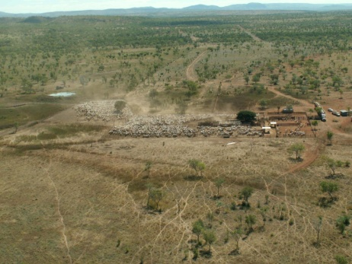
Slide 2  - Improving the fertility of Brahman cattle through selection has the potential to increase the profitability of cattle properties in northern Australia. | 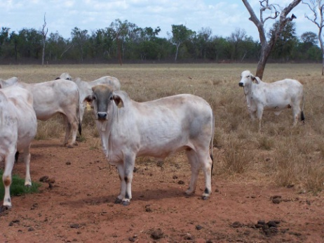
Slide 3  - Selected Brahman herd  - Project Aim: To investigate the gains in productivity that can be made through selection for fertility in a Brahman herd | 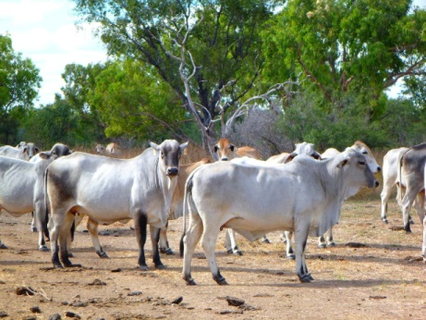

Slide 4  - NT DoR has a Brahman herd that has been selected for fertility since 1994.  - Joined BREEDPLAN in 1994 (incorporating performance data back to 1986).  - Located in VRD since 2002. Previously Douglas Daly.  - Significant progress has been made through selection for fertility | 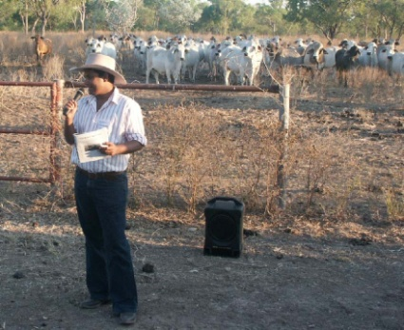
Slide 5  - Selection involved:  - Females  - Cows were culled if they did not raise a calf each year (except 1st calf heifers)  - Heifers mated as yearlings for a period of three months.  - Heifers must wean 2 calves in 3 years following yearling mating. In years with high pregnancy rates can be even stricter – higher selection pressure. | 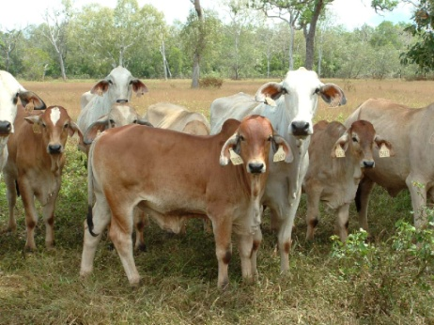
Slide 6  - Bull selection  - AI sires (used in heifers) Selected using a selection index that places high importance on fertility EBVs. Only from herds known to cull non pregnant cows  - Bulls bred within the herd were selected for use as yearlings on the basis of a selection index that placed emphasis on:  - large scrotal size as yearlings  - high 400 day weight  - high percentages of normal sperm (as yearlings)  - low age of their dam at calving and high dam "never miss a calf" scores. | 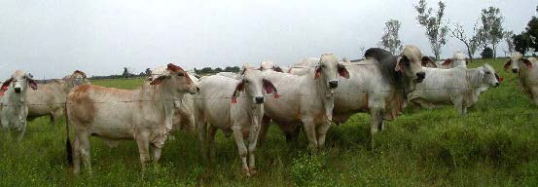

Slide 7  - A number of studies have shown that lower heifer age at puberty is associated with improved fertility at later ages. It has been suggested that age at puberty may be the best measure of inherent fertility (Martin et al. 1992).  - Experiment to test whether selection had been successful in improving heifer fertility : Compared the pregnancy rates from yearling mating in :  - Heifers from the selected herd (SEL) vs Heifers sourced from NT commercial properties (COM) | 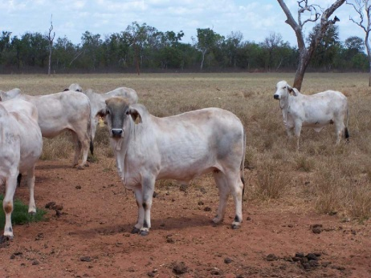
Slide 8  - After weaning SEL, and COM heifers were transported to DDRF and mated there as yearlings  - 3 year groups - Each year about 100 1st round weaner heifers were purchased from a (different) commercial property and compared to heifers from the SEL herd (avg N = 31) in the same weight range (220-300kg)  - Joined from late Dec to end of March  - Pregnancy test 2 months after end of joining (ultrasound)  - Compare pregnancy rates – SEL vs COM | 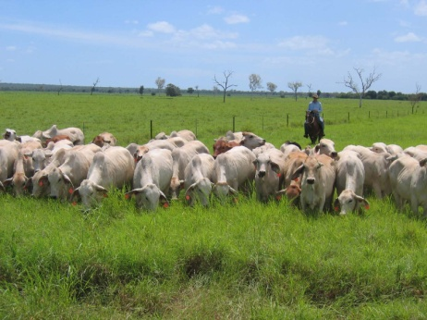
Slide 9  - Results:  - In each year pregnancy rate from yearling mating was significantly higher in SEL heifers  - On average SEL +35%  - Each year the average joining weight was higher (not sig.) in the COM mob | 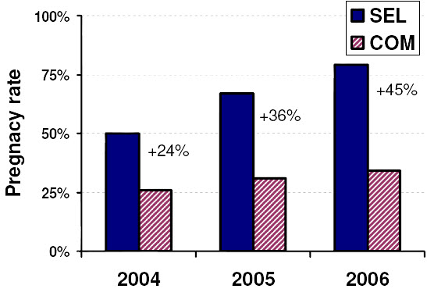

Slide 10  - Greater difference in pregnancy rate (between the SEL and COM heifers) than previous studies.  - Most likely because heifers were mated a year earlier (as yearlings) in this study.  - When heifers don't conceive from yearling mating it is likely to be because they have not reached puberty by the end of the mating period.  - Average age at puberty for Brahman heifers = 750 days (Johnston et al. 2009)  - More SEL heifers had reached puberty by the end of mating as yearlings | 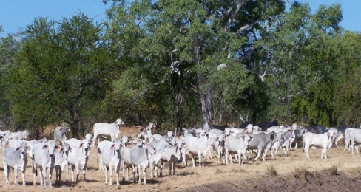
Slide 11  - A number of studies have shown that lower heifer age at puberty is associated with improved fertility at later ages.  - Selection for fertility traits in a Brahman herd has produced an earlier maturing, more fertile herd  - Pregnancy rates from yearling mating were increased by 35%  - Industry Brahmans – 30%  - Selected Brahmans – 65% | 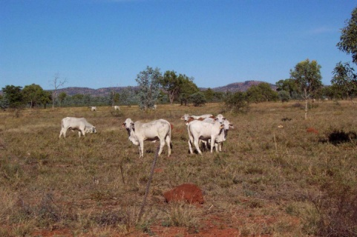
Slide 12  - This has been backed up by results from the breeder herd. | 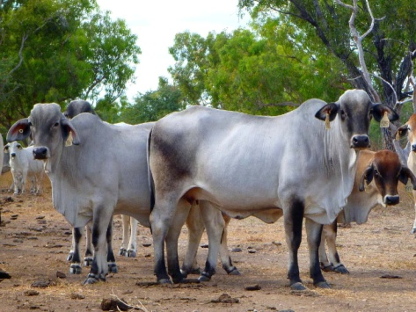

Slide 13

- Response to selection for fertility
- Graphs: The change over time in fertility EBVs in the SEL herd and the Brahman breed society average.
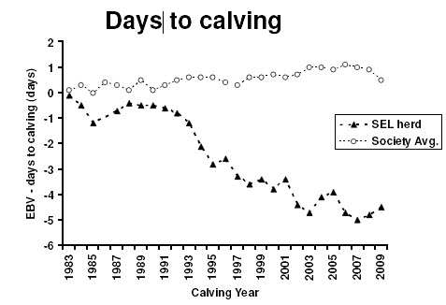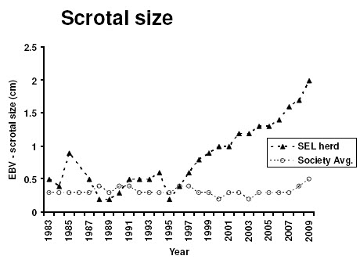
Slide 14  - VRRS breeder comparison  - Assessed fertility of the SEL herd: compare pregnancy rates of lactating cows at WR1. SEL herd vs unselected Brahman control (CON) herd.  - The herds were stocked at the same utilisation rate and managed in the same way, except that the CON herd was continuously mated while the SEL herd was control mated.  - Therefore only CON cows that were due to calve at the same time as SEL cows (assessed by pregnancy testing) were compared. | 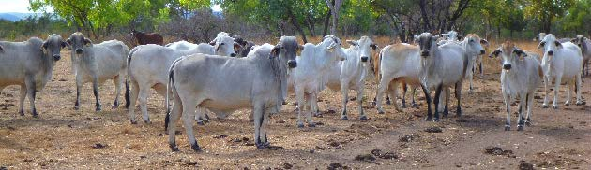
Slide 15  - Pregnancy rates in lactating cows at WR1 were 37% higher on average than in an unselected herd between 2004 and 2009 | 