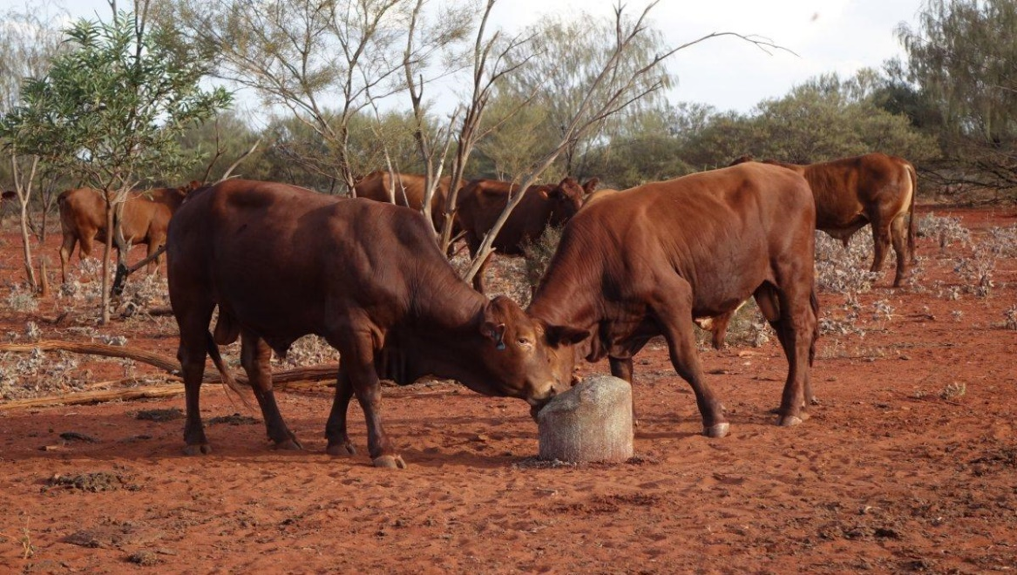
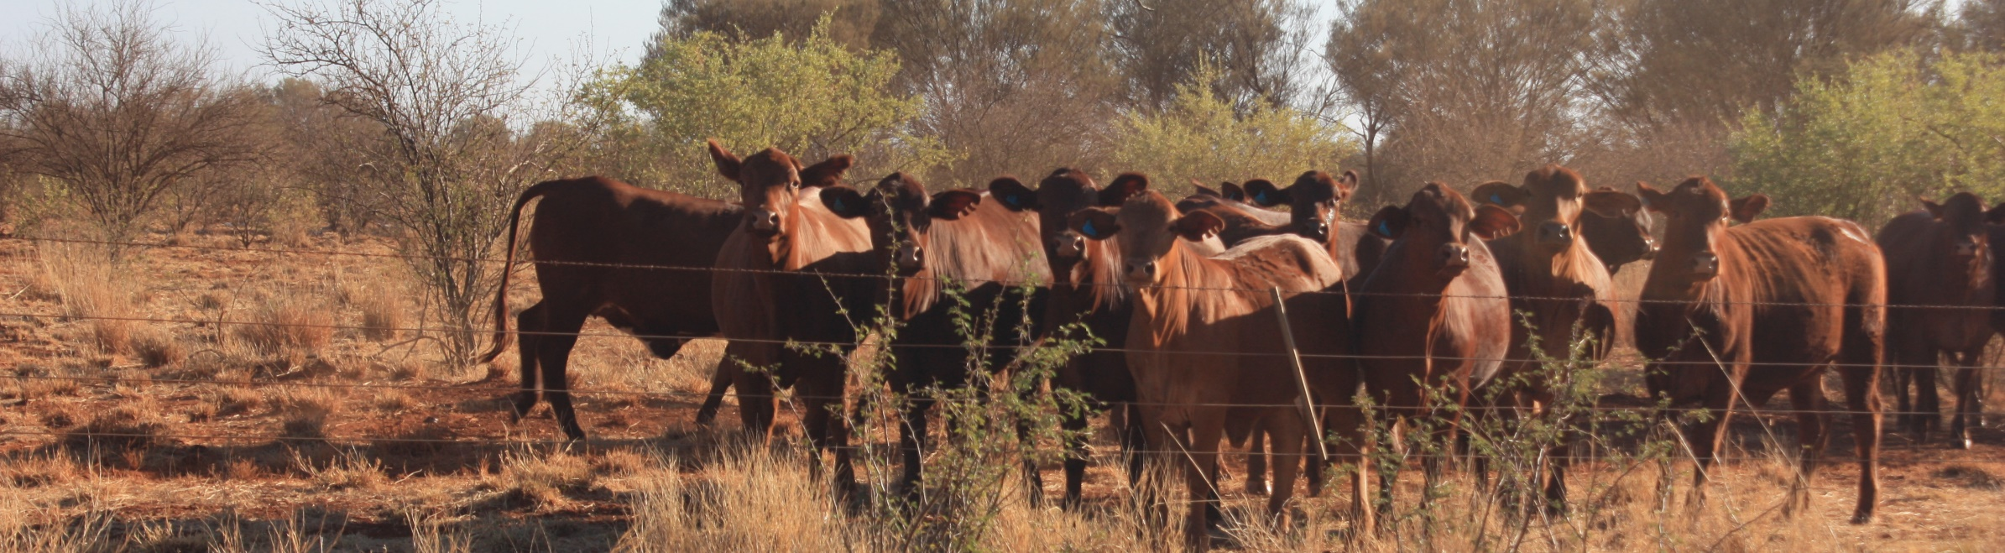
Karratha, WA: 9-11 December 2017

VENUE The Quarter, Sharp Avenue, Karratha (plus paddock exercises)
TIME 8:30am to 5:00pm

Nutrition EDGE is a three-day workshop and practical session covering all aspects of animal nutrition.
Participants will be able to make better decisions to achieve their herd performance targets through improved breeder fertility, weight gains, reduced mortality, optimal use of supplements and overall management.
What you will learn
- importance of nutrition
- how to get your bottom line to benefit
- digestion and nutrients
- pasture intake, quality and diet quality
- pasture growth, intake and forage budgeting
- calculating a forage budget
- mineral nutrition
- diagnosing deficiencies
- supplementation and other tools
- supplement groups
- reading a label
- practical nutrition management
- defining production targets
- calculating viability of options

Attending this workshop will help you to:
- better understand the nutritional requirements of your cattle and sheep
- estimate the feed value of pasture and animal production
- know what supplements to feed
- understand a feed label
- save money on supplementary and drought feeding
- make better management decisions for a range of seasonal conditions

Price
$1,750 + GST / 1st person from one business
$1,450 + GST / 2 or more people from one business

Cost includes comprehensive set of workshop notes, workbook and lunch, morning and afternoon tea each day.

Places are limited. To register contact:

Désirée Jackson
M: 0409 062 692 or E: desireejackson@bigpond.com

Matt Fletcher
M: 0428 637 710 or E: Matthew.Fletcher@dpird.wa.gov.au

Deliverers:

Désirée Jackson - Désirée Jackson Livestock Management
Matt Fletcher - DPIRD, Kununurra

