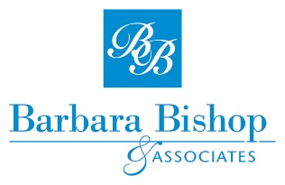
Profit through People – Managing People
Registration Form

Rockhampton – 19-21 July 2016
Apartments on Palmer, 5 Palmer Street, Rockhampton
YOUR DETAILS
Title: Mr / Mrs / Miss/ Ms | First Name: |  |  | Surname:
Address:

Town: |  |  | State: |  | Postcode:
Phone: |  |  | Mobile:
Email address:

Employer:

Any special dietary requirements?

PAYMENT DETAILS
Registration Deposit (non-refundable – Can be used for another registration within 12 months). |  | $300.00 (deducted from the total cost)
Full Course Fee/Person (this includes workshop, resource book, morning & afternoon tea, lunches and dinner on the first night.) |  | $1125.00 (plus GST)
Discounts Available
- 3 or more participants from the same Company - $956.25/person (plus GST)
- Early Bird – Book and pay in full one month prior to Course date - $990/person (plus GST)
Total Fee Enclosed/Transferred |  | $
METHOD OF PAYMENT
How are you paying for your course? |  | □ Direct Deposit to our Account: BSB124001 Account No. 20153550
 |  | □ Bank Cheque – Payable to Barbara Bishop
 |  | □ Send me an invoice for direct debit
TERMS & CONDITIONS
Deposit & Payment:
- A minimum deposit of $300 is required to confirm your registration. This deposit is non-refundable.
- The deposit can be transferred to an alternative course or person for a period of 12 months.
- To receive the Early Bird offer, full payment must be received at least one month prior to the commencement of the course.
- If outside of Early Bird offer, the balance of fees must be paid at least 14 days prior to the commencement of the course.
Privacy Statement:
Barbara Bishop & Associates is committed to ensuring the privacy of all information it collects. Personal information supplied to Barbara Bishop & Associates on this registration form will be used for registration processing, course follow up and project work.

Once you have completed this form please email or post to:
Barbara Bishop & Associates | barbarabishop@bigpond.com | PO Box 4262, Forest Lake Qld 4078

